caGrid 1.1 CORE Service Use Case
NCIA

Last Revised: | 5/08/2008
Produced By: | NCIA team

Document Approvals
The list contains the name and contact information for the core project team and any key stakeholders who have an interest in the success of the project. An “S” identifies persons responsible for approval from the stakeholder groups. Sign off of the document would be required when a decision is made not to take action for defined gaps.

S | Name | Role
S | Anand Basu | NCICB Engineering Manager
 | David Palmer | Project Manager
 | Jennifer Zeng | Technical Lead
 | Larry Holeman | Requirements Analyst
S | John Freymann | Customer Liaison
S | Anand Basu | NCICB Engineering Manager

Revision History
When you make a change to a document, you must add an entry to this Revision History table and you must manually type the Last Revised Date on the front cover.

Date | Version | Description | Revised by
05/08/2008 | 1 | Document built using the caGrid Transfer Service as a baseline and edited accordingly | Larry Holeman, Carl Blake
Copyrights and Trademarks
© Copyright 2008 by NCICB, caBIGTM. All rights reserved.

Table of Contents
1. Use Case: caGrid 1.1 CORE Service 1
1.1 Use Case Diagram 1
1.2 Brief Description 1
1.2.1 References 1
1.4 Preconditions 2
1.4.1 None 2
1.4.2 External system has access to the CaGrid 2
1.5 Basic Flow of Events 2
1.6 Post Conditions 2

Use Case: caGrid 1.1 Query Service

Use Case Diagram
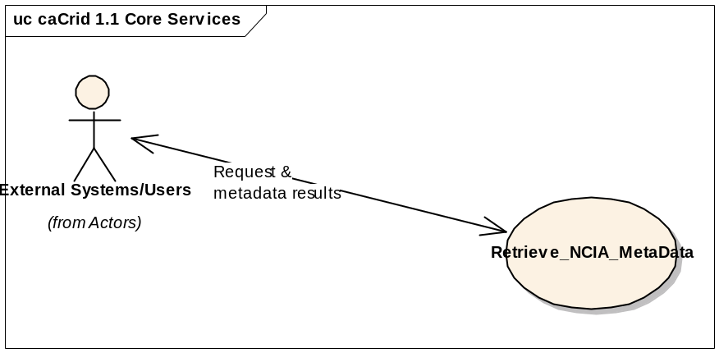

Brief Description
This Use Case describes the capability to provide the ability for users and systems to query via the NCIA data service API and access image metadata associated with one or more images and other data objects across the grid. An external user at remote sites uses their external systems such as I-Response, VirtualPacs, and XIP Host will access NCIA Image repository through the NCIA caGrid. The systems that have a diverse configurations and software will convert their request to the NCIA query standard (CQL) for transmission.

References
- Future request Tracker (https://gforge.nci.nih.gov/tracker/?func=detail&group_id=312&aid=6867&atid=1285)
- (http://www.cagrid.org/nwiki/index.php?title=CaGridtransfer)
  - Primary Actors
External user/System that utilizes a backend conversion process to convert their query request into the NCIA standard query request (CQL).

Preconditions

None

External system has access to the CaGrid

Basic Flow of Events

NCIA shall provide Retrieve_NCIA_MetaData that accepts requests from external users/sources and return metadata based on the request.

Post Conditions

  - Requirements

    - Requirements for (6867): NCIA system shall provide the ability to down load a group of images over the caGrid Infrastructure.

a. (6867.1) NCIA shall provide a Retrieve NCIA MetaData function that will accept requests from external users/sources and return domain Metadata based on the request.
b. (6867.2) NCIA shall provide a Retrieve DICOM Data function that will accept selection criteria from external users/sources and return images based on that criteria.

2. Use Case: Retrieve_NCIA_MetaData
2.1 Brief Description
The purpose of this Use Case is to facilitate the acceptance and transfer of metadata to an external system/user. NCIA will provide NCIA services that accept requests from external users/sources and return metadata based on the request.

2.2 Preconditions

2.3 Basic Flow of Events
1. This use case begins when an external user elect to submit a request for information/data to NCIA caGrid 1.1 CORE Service.
a. Retrieve_NCIA_MetaData accept and evaluate the request by examining the domain target, attributes, and predicate of the request to determine the query content.
1. External System/user establishes communication with NCIA caGrid Transfer Service.
2. Retrieve_NCIA_MetaData accepts CQL query
3. Retrieve_NCIA_MetaData queries the NCIA database
4. Retrieve_NCIA_MetaData processes query results
5. Retrieve_NCIA_MetaData returns query results as CQL query result
6. Query Results is retrieved by external system/user
2. The external user may drill down to images of interest by resubmitting request using information/data from previous requests.

Use Case End
2.4 Alternative Flows
None
2.5 Exceptions
1. Exception 1: No Data Available for Requested Query
Returns an indication noting no data is available for the available Request.
End exception 1
2. Exception 2: Request unrecognizable
Returns an indication noting that the CQL query cannot be processed.
End exception 2
3. Exception 3: Access Denied
Returns a message stating that “You do not have permissions to access requested data”. (applies for attempts to access private data)
End exception 3
2.6 Post Conditions
1. Post Condition 1:
The system is ready to accept another CQL query.
2.7 Special Requirements
None

2.8 Data
1. Data Request Sample
The request will be converted regardless of source to a CQL Query Format.
Example: Find Patient with Patient Name = “John Doe” AND Patient ID = “12345”
<Target name=”gov.nih.nci.ncia.domain.Patient”>
<Group logicRelation=”AND”>
<Attribute name=”patientName” predicate=”EQUAL_TO” value=”John Doe”/>
<Attribute name=”patientid” predicate=”EQUAL_TO” value=”12345”/>
</Group>
</Target>

2. Domain Data Objects
a. ClinicalTrialSponsor
b. ClinicalTrailProtocol
c. ClinicalTrailSubject
d. ClinicalTrailSite
e. TrailDataProvenance
f. Patient
g. CurationData
h. Study
i. Annotation
k. Equipment
l. Series
m. Image

